1. What is flutter? features and benefits of flutter?

Flutter is a versatile framework developed by Google in 2015 that allows developers to build applications for Android, iOS, web, and desktop using a single codebase. Its key feature is its low development time, made possible by tools like **hot reload** and **hot restart**, which enable developers to see real-time changes without restarting the app.  
The main benefit of Flutter is its ability to create visually attractive applications with high performance while ensuring platform consistency. Additionally, it offers an extensive set of pre-built widgets and integrates well with various platforms, making development efficient and seamless.

1. What is dart? why should we use dart as the programming language?

Dart is a modern programming language designed by Lars and Kasper and developed by Google. It is object-oriented and similar to Java in terms of syntax, making it easier for developers with Java experience to adapt quickly.  
Dart is specifically optimized for UI development with frameworks like Flutter. Its fast compilation to native code and support for asynchronous programming make it an ideal choice for building high-performance, cross-platform applications.

1. How is the basic program of dart written?

Dart programs typically start with the main.dart file, located in the lib folder of a Flutter project. The program execution begins with the main() function, which serves as the entry point of the application. Other functions and methods can be defined and called within this structure, ensuring a modular and organized codebase.

1. What do you mean by widgets?

Widgets are the fundamental building blocks used to construct the user interface (UI) of a Flutter app. They define the visual and functional elements of the app. Examples of widgets include **Container**, **Column**, **Row**, **ListView**, **ElevatedButton**, and many more.  
Widgets can be classified as **stateless** or **stateful**, depending on whether their state changes during runtime.

1. What do you mean by stateless widgets?

A **stateless widget** is a widget that remains immutable throughout its lifecycle. Once it is built, its appearance and properties cannot be dynamically updated. Stateless widgets are typically used for UI elements that do not require user interaction or data changes.  
For example, a static text label or an icon can be implemented as a stateless widget.

1. What is stateful widgets?

A **stateful widget** is a widget that can update its appearance dynamically based on user interaction or changes in data. It holds a mutable "state" object, and whenever the state is updated, the widget rebuilds itself to reflect the changes.  
Stateful widgets are commonly used for features like forms, animations, or any element that involves interactivity.

1. what is the structure of files in flutter?

The file structure in Flutter is well-organized and includes the following:

* The **entry point** is main.dart, located in the lib folder. This file contains the main() function, where the application execution begins.
* All dependencies are managed in the pubspec.yaml file under the dependencies: section. This file is also used to configure assets and packages.
* To include assets like images or fonts, a dedicated **assets folder** should be created at the root of the project. The assets must also be listed in the pubspec.yaml file to make them accessible in the project.

**Basic App for profile**

**Code:**

**main.dart**

import 'package:flutter/material.dart';  
import 'package:get/get.dart';  
import 'package:profile/Screens/profile.dart';  
  
void main() {  
 WidgetsFlutterBinding.ensureInitialized();  
 runApp(const MyApp());  
}  
  
class MyApp extends StatelessWidget {  
 const MyApp({super.key});  
  
 @override  
 Widget build(BuildContext context) {  
 return GetMaterialApp(  
 debugShowCheckedModeBanner: false,  
 title: 'Flutter Demo',  
 home: ProfileScreen(),  
 );  
 }  
}

**profile.dart**

import 'package:flutter/material.dart';  
import 'package:get/get.dart';  
import 'package:url_launcher/url_launcher.dart';  
import 'dart:math' as math;  
  
class ProfileScreen extends StatefulWidget {  
 const ProfileScreen({super.key});  
  
 @override  
 State<ProfileScreen> createState() => _ProfileScreenState();  
}  
  
class _ProfileScreenState extends State<ProfileScreen> {  
 Future<void> _launchURL(String urlString) async {  
 final Uri url = Uri.parse(urlString);  
 try {  
 if (!await launchUrl(url)) {  
 ScaffoldMessenger.of(context).showSnackBar(  
 SnackBar(content: Text('Could not launch $urlString')),  
 );  
 }  
 } catch (e) {  
 debugPrint('Error launching $urlString: $e');  
 ScaffoldMessenger.of(context).showSnackBar(  
 SnackBar(content: Text('Failed to open $urlString')),  
 );  
 }  
 }  
  
 String about =  
 "I am currently pursuing a Master of Computer Applications (MCA) from Sardar Patel Institution of Technology with a strong foundation in software development. I have hands-on experience in Flutter development, building efficient and user-friendly mobile applications for iOS and Android. My interests lie in full-stack development and backend development, where I aim to deepen my expertise in creating robust, scalable systems. I’m always eager to learn new technologies and contribute to innovative projects.";  
  
 String CIM =  
 "The CRM mobile app for Colliers enables users to manage properties, listings, transactions, companies, contacts, and bookmarks with real-time search and filtering. Key features include a dashboard with widgets for buildings, supply, transactions, and options; recent activity tracking; bookmarking across all modules; detailed building pages with stacking plans and transaction history; supply, listing, company, and contact management; and an option module for bundling properties and generating reports. The app supports multi-lingual functionality and works on iOS and Android platforms.";  
 String WMS =  
 "The Warehouse Management System includes key modules such as Putaway, Picking, Packing, PDV, Bin Movement, and Cycle Count. In the Putaway module, boxes or packages are scanned and stored in designated bin locations. The Picking module involves retrieving boxes or packages from bin locations for dispatch. The Packing module allows for breaking larger quantities into single pieces if necessary. PDV, Bin Movement, and Cycle Count manage other essential warehouse operations, ensuring organized storage, efficient retrieval, and accurate inventory tracking. The system streamlines warehouse processes, improving efficiency and accuracy in managing inventory flow.";  
 String SAS =  
 "The automatic attendance system leverages RFID technology to streamline attendance tracking. Each student is assigned an RFID card, which records attendance data upon scanning. This data is first stored in Google Sheets, where real-time updates and data manipulation occur. Once processed, the information is pushed to Firebase Database for secure storage and access. The application provides distinct logins for both admins and students. Admins can register students, manage records, and monitor attendance. Students can access their subject-wise and overall attendance and check the defaulters list. This system automates attendance management, improving efficiency and accuracy through seamless data integration.";  
  
 String ach1 =  
 "Ranked 3 in Khelo India University Games in the sport Mallakhamb - 2023. National Player in Mallakhamb, played and got ranked in various State Level and National Level Competition.";  
 String ach2 =  
 "I have had the privilege of performing Mallakhamb as a stage artist on international platforms across various countries, including Australia, Budapest, Mexico, and Bahrain. These performances showcased the traditional Indian sport to a global audience, allowing me to share my passion for this unique art form on an international stage.";  
  
 final List<Map<String, String>> imageItems = [  
 {'imagePath': 'assets/images/1.jpeg', 'title': 'Acrobatic Dynamic'},  
 {'imagePath': 'assets/images/2.jpeg', 'title': 'MoonKnight'},  
 {'imagePath': 'assets/images/3.jpeg', 'title': 'CWG 2018'},  
 {'imagePath': 'assets/images/4.jpeg', 'title': 'CWG 2018'},  
 {'imagePath': 'assets/images/5.jpeg', 'title': 'CWG 2018'},  
 {'imagePath': 'assets/images/6.jpg', 'title': 'Khelo India 2023'},  
 ];  
 final CarouselController controller = CarouselController(initialItem: 1);  
  
 @override  
 Widget build(BuildContext context) {  
 return Scaffold(  
 appBar: AppBar(  
 // toolbarHeight: 100,  
 centerTitle: true,  
 title: Text("Profile"),  
 ),  
 body: CustomScrollView(slivers: [  
 SliverAppBar(  
 expandedHeight: Get.height * 0.4,  
 pinned: true,  
 backgroundColor: Colors.white, // Set background color to white  
 flexibleSpace: LayoutBuilder(  
 builder: (context, constraints) {  
 // Calculate the progress of the collapse (0.0 to 1.0)  
 final progress = 1.0 -  
 (constraints.maxHeight - constraints.minHeight) /  
 (Get.height * 0.4 - kToolbarHeight);  
  
 // Ensure progress is between 0 and 1  
 final safeProgress = math.max(0.0, math.min(1.0, progress));  
  
 return FlexibleSpaceBar(  
 title: Row(  
 mainAxisAlignment: MainAxisAlignment.start,  
 children: [  
 if (safeProgress > 0.5)  
 Text(  
 "Atharva Vasant Angre",  
 style: TextStyle(  
 fontSize: 25,  
 color: Colors.black,  
 fontWeight: FontWeight.bold,  
 ),  
 ),  
 ],  
 ),  
 background: Column(  
 mainAxisAlignment: MainAxisAlignment.center,  
 children: [  
 ClipOval(  
 child: Image.asset(  
 'assets/images/profileImage.png',  
 height: Get.height * 0.25,  
 width: Get.height * 0.25,  
 fit: BoxFit.cover,  
 ),  
 ),  
 SizedBox(height: 16),  
 Text(  
 "Atharva Vasant Angre",  
 style: TextStyle(  
 fontSize: 35,  
 color: Colors.black,  
 fontWeight: FontWeight.bold,  
 ),  
 ),  
 ],  
 ),  
 );  
 },  
 ),  
 ),  
 SliverList(  
 delegate: SliverChildListDelegate(  
 [  
 SizedBox(height: Get.height * 0.02),  
 Row(  
 mainAxisAlignment: MainAxisAlignment.spaceEvenly,  
 children: [  
 // GitHub  
 GestureDetector(  
 onTap: () => _launchURL('https://github.com/angreatharva'),  
 child: Container(  
 height: Get.height * 0.08,  
 width: Get.width * 0.2,  
 padding: EdgeInsets.symmetric(horizontal: Get.width * 0.025,vertical: Get.height * 0.005),  
 decoration: BoxDecoration(  
 color: Color(0xffffd146),  
 borderRadius: BorderRadius.all(Radius.circular(8)),  
 border: Border.all(color: Colors.black, width: 2.5),  
 ),  
 child: Image.asset(  
 'assets/images/git1.png',  
 height: Get.height * 0.050,  
 ),  
 ),  
 ),  
  
 // Email  
 GestureDetector(  
 onTap: () => _launchURL(  
 'mailto:angreatharva08@gmail.com?subject=Greetings&body=Hello'),  
 child: Container(  
 height: Get.height * 0.08,  
 width: Get.width * 0.2,  
 padding: EdgeInsets.symmetric(horizontal: Get.width * 0.025,vertical: Get.height * 0.005),  
 decoration: BoxDecoration(  
 color: Color(0xffffd146),  
 borderRadius: BorderRadius.all(Radius.circular(8)),  
 border: Border.all(color: Colors.black, width: 2.5),  
 ),  
 child: Icon(Icons.mail_outline_rounded, size: 60),  
 ),  
 ),  
  
 // LinkedIn  
 GestureDetector(  
 onTap: () => _launchURL(  
 'https://www.linkedin.com/in/atharva-angre-3146aa269/'),  
 child: Container(  
 height: Get.height * 0.08,  
 width: Get.width * 0.2,  
 padding: EdgeInsets.symmetric(horizontal: Get.width * 0.025,vertical: Get.height * 0.005),  
 decoration: BoxDecoration(  
 color: Color(0xffffd146),  
 borderRadius: BorderRadius.all(Radius.circular(8)),  
 border: Border.all(color: Colors.black, width: 2.5),  
 ),  
 child: Image.asset(  
 'assets/images/linkedIn.png',  
 height: Get.height * 0.05,  
 ),  
 ),  
 ),  
  
 // Phone  
 GestureDetector(  
 onTap: () => _launchURL('tel:+919167449720'),  
 child: Container(  
 height: Get.height * 0.08,  
 width: Get.width * 0.2,  
 padding: EdgeInsets.symmetric(horizontal: Get.width * 0.025,vertical: Get.height * 0.005),  
 decoration: BoxDecoration(  
 color: Color(0xffffd146),  
 borderRadius: BorderRadius.all(Radius.circular(8)),  
 border: Border.all(color: Colors.black, width: 2.5),  
 ),  
 child: Icon(Icons.phone_android_rounded, size: 50),  
 ),  
 ),  
 ],  
 ),  
 SizedBox(height: Get.height * 0.02),  
 Column(  
 spacing: Get.height * 0.02,  
 children: [  
 Container(  
 width: Get.width * 0.95,  
 height: Get.height * 0.35,  
 padding: EdgeInsets.all(8),  
 decoration: BoxDecoration(  
 borderRadius: BorderRadius.all(Radius.circular(8)),  
 border: Border.all(color: Colors.black, width: 2.5),  
 color: Color(0xffbed5ea),  
 ),  
 child: Text(  
 about,  
 style:  
 TextStyle(fontWeight: FontWeight.w700, fontSize: 18),  
 ),  
 ),  
 Container(  
 width: Get.width * 0.95,  
 height: Get.height * 0.35,  
 padding: EdgeInsets.all(8),  
 decoration: BoxDecoration(  
 borderRadius: BorderRadius.all(Radius.circular(8)),  
 border: Border.all(color: Colors.black, width: 2.5),  
 color: Color(0xffbed5ea),  
 ),  
 child: Scrollbar(  
 thumbVisibility: true,  
 child: SingleChildScrollView(  
 child: Column(  
 crossAxisAlignment: CrossAxisAlignment.start,  
 spacing: Get.height * 0.015,  
 children: [  
 Text(  
 "Project",  
 style: TextStyle(  
 fontWeight: FontWeight.w700, fontSize: 25),  
 ),  
 Column(  
 crossAxisAlignment: CrossAxisAlignment.start,  
 children: [  
 Text(  
 "ReConnect",  
 style: TextStyle(  
 fontWeight: FontWeight.w900,  
 fontSize: 20),  
 ),  
 Text(  
 CIM,  
 style: TextStyle(  
 fontWeight: FontWeight.w700,  
 fontSize: 18),  
 ),  
 ],  
 ),  
 Column(  
 crossAxisAlignment: CrossAxisAlignment.start,  
 children: [  
 Text(  
 "WMS",  
 style: TextStyle(  
 fontWeight: FontWeight.w900,  
 fontSize: 18),  
 ),  
 Text(  
 WMS,  
 style: TextStyle(  
 fontWeight: FontWeight.w700,  
 fontSize: 18),  
 ),  
 ],  
 ),  
 Column(  
 crossAxisAlignment: CrossAxisAlignment.start,  
 children: [  
 Text(  
 "Smart Attendance System",  
 style: TextStyle(  
 fontWeight: FontWeight.w900,  
 fontSize: 18),  
 ),  
 Text(  
 SAS,  
 style: TextStyle(  
 fontWeight: FontWeight.w700,  
 fontSize: 18),  
 ),  
 ],  
 ),  
 ],  
 ),  
 ),  
 ),  
 ),  
 Container(  
 width: Get.width * 0.95,  
 height: Get.height * 0.38,  
 padding: EdgeInsets.all(8),  
 decoration: BoxDecoration(  
 borderRadius: BorderRadius.all(Radius.circular(8)),  
 border: Border.all(color: Colors.black, width: 2.5),  
 color: Color(0xffbed5ea),  
 ),  
 child: Scrollbar(  
 thumbVisibility: true,  
 child: SingleChildScrollView(  
 child: Column(  
 crossAxisAlignment: CrossAxisAlignment.start,  
 children: [  
 Text(  
 "Achievements",  
 style: TextStyle(  
 fontWeight: FontWeight.w700, fontSize: 25),  
 ),  
 Text(  
 ach1,  
 style: TextStyle(  
 fontWeight: FontWeight.w700, fontSize: 18),  
 ),  
 Text(  
 ach2,  
 style: TextStyle(  
 fontWeight: FontWeight.w700, fontSize: 18),  
 ),  
 ],  
 ),  
 ),  
 ),  
 ),  
 Container(  
 width: Get.width * 0.95,  
 height: Get.height * 0.35,  
 padding: EdgeInsets.all(8),  
 decoration: BoxDecoration(  
 borderRadius: BorderRadius.all(Radius.circular(8)),  
 border: Border.all(color: Colors.black, width: 2.5),  
 color: Color(0xffbed5ea),  
 ),  
 child: CarouselView.weighted(  
 controller: controller,  
 itemSnapping: true,  
 flexWeights: const <int>[1,7,1],  
 children: imageItems.map((Map<String, String> item) {  
 return HeroLayoutCard(  
 imagePath: item['imagePath']!,  
 title: item['title']!,  
 );  
 }).toList(),  
 ),  
 ),  
 SizedBox(height: Get.height * 0.005)  
 ],  
 )  
 ],  
 ))  
 ]));  
 }  
}  
class HeroLayoutCard extends StatelessWidget {  
 const HeroLayoutCard({  
 Key? key,  
 required this.imagePath,  
 required this.title,  
 }) : super(key: key);  
  
 final String imagePath;  
 final String title;  
  
 @override  
 Widget build(BuildContext context) {  
 return Container(  
 margin: const EdgeInsets.symmetric(horizontal: 8),  
 child: ClipRRect(  
 borderRadius: BorderRadius.circular(12),  
 child: Stack(  
 fit: StackFit.expand,  
 children: <Widget>[  
 Image.asset(  
 imagePath,  
 fit: BoxFit.cover,  
 ),  
 Positioned(  
 bottom: 0,  
 left: 0,  
 right: 0,  
 child: Container(  
 padding: const EdgeInsets.all(16),  
 decoration: BoxDecoration(  
 gradient: LinearGradient(  
 begin: Alignment.topCenter,  
 end: Alignment.bottomCenter,  
 colors: [  
 Colors.transparent,  
 Color(0xff1e1818),  
 ],  
 ),  
 ),  
 child: Column(  
 crossAxisAlignment: CrossAxisAlignment.start,  
 children: <Widget>[  
 Text(  
 title,  
 style: Theme.of(context)  
 .textTheme  
 .headlineLarge  
 ?.copyWith(color: Colors.white),  
 ),  
 ],  
 ),  
 ),  
 ),  
 ],  
 ),  
 ),  
 );  
 }  
}

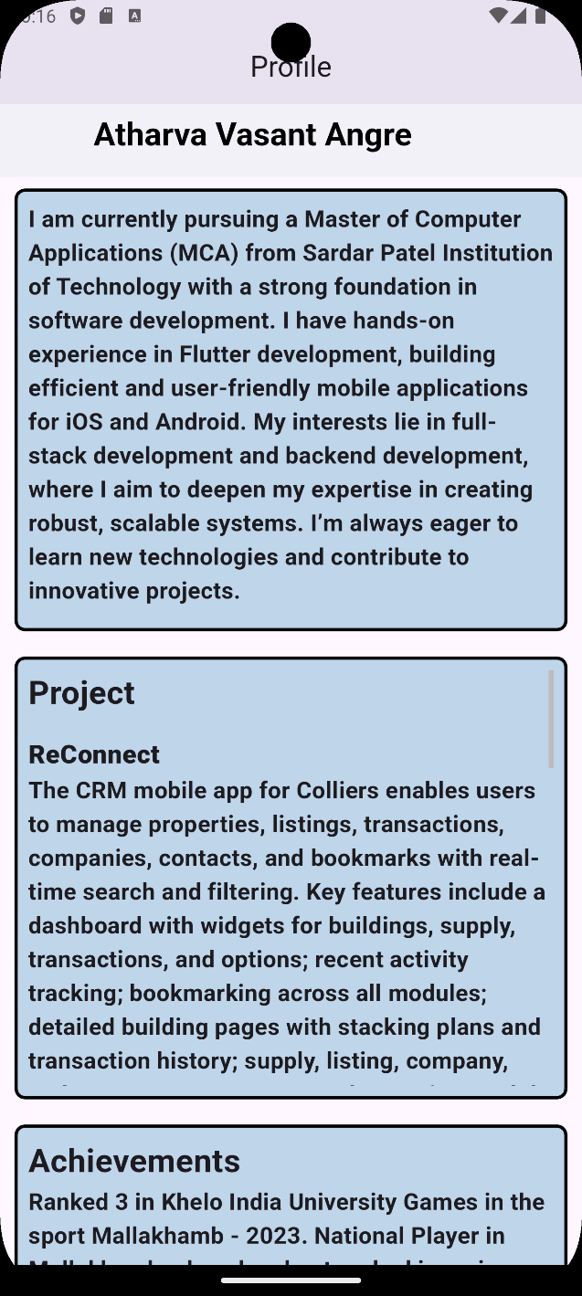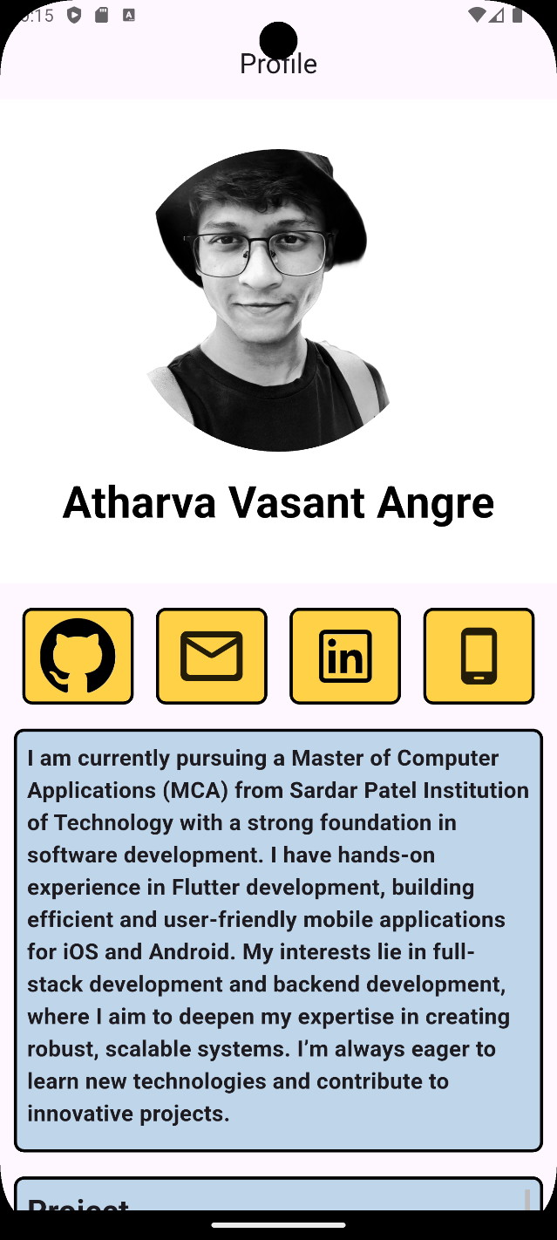**Outputs:**

